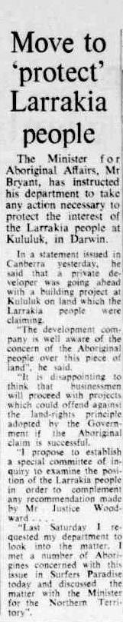
Canberra Times, 10 July, 1973. “Move to 'protect' Larrakia people.”

The Minister for Aboriginal Affairs, Mr Gordon Bryant, has instructed his department to take any action necessary to protect the interest of the
Larrakia people at Kululuk [sic], in Darwin.
In a statement issued in Canberra yesterday, he said that
a private developer was going ahead with a building project
at Kululuk on land which the Larrakia people were claiming.
“The development company is well aware of the concern of the
Aboriginal people over this piece of land,” he said.
“It is disappointing to think the businessmen will proceed with projects which could offend against the land-rights principle
adopted by the Government if the Aboriginal claim is successful.
“I propose to establish a special committee of inquiry
to examine the position of the Larrakia people
in order to complement any recommendation
made by Mr Justice Woodward ...
“Last Saturday I requested my department to look into the matter.
I met a number of Aborigines concerned with this issue in Surfers Paradise
today and discussed the matter with the Minister for the Northern Territory”.

